A000-Afr-Sorko Culture-Head-Semitic-Terracotta-19th c

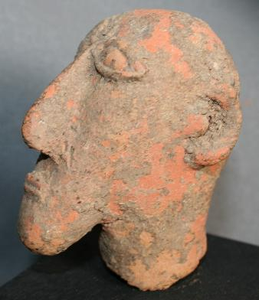 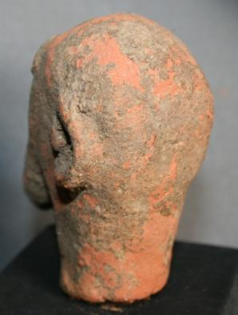

This very rare terracotta head of a male with Semitic features dates to the 14th-15th centuries when Arab and Jewish traders were traveling caravan routes across the Sahara desert to the trading areas of west Africa along the Niger River. This terracotta was excavated in Djenné which houses an ancient Mosque that dates to the 14th century. This individual, who was of high rank, may have been one of the leaders who was responsible for the building of the Mosque.

* The Sorko people also used locally available clay to produce unusual terracotta clay busts.
* These appear to have been of famous trans-Saharan Arab traders of which the present collection has two

The Sorko (or Bozo), a West African ethnic group, are considered "the masters of the river" and **are** the principal fishing people of the Inner Niger Delta in Mali. The name *Bozo* is thought to derive from the neighboring Bambara people's word "*bo-so*," meaning "bamboo" or "grass house" which has been accepted as referring to the whole of the ethnic group. However, local people refer to themselves by one of four dialects: Hainyaho (a few thousand speakers), Tièma cièwe (2,500 speakers in 1991), Tiéyaho (a few thousand speakers) and Sorko or Sorogama (200,000 speakers in 2005) all of which form a branch of northwestern Mande languages.

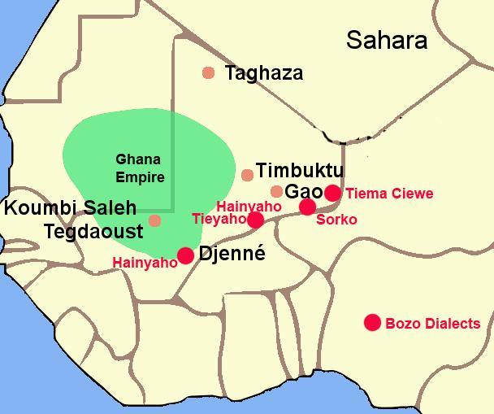

The Ghana Empire 1000-1400 CE showing the ethnolinguistic groups along the Niger River. After https://i.pinimg.com/564x/c6/a7/9b/c6a79b7443105f363ff965ebf420b7fd.jpg

and the other of a **dual wedding party being escorted along the Niger River in a crocodile-prow fishing pirogue**.

The Sorko culture took shape under the Ghana Empire in what is now southeastern Mauritania and western Mali that was founded before 830 CE, when the Bozo took possession of the banks of the Niger. This event was of great importance since the domesticated camel provided transport for trans-Saharan trade in gold, ivory, salt and natron which could then be exchanged for manufactured goods to Mediterranean ports connecting to Europe, to Egypt and to the Middle East.

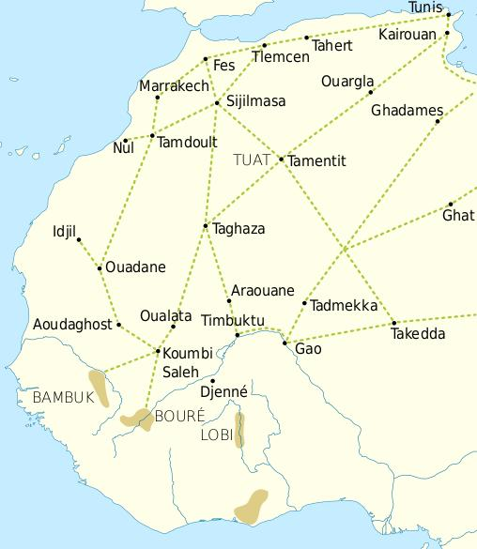

Trade routes of the Western Sahara c. 1000-1500. Goldfields are indicated by light brown shading. After https://i.pinimg.com/564x/69/15/ce/6915ce6f4fd34025787fe59bd44f9eae.jpg

This trade resulted in an increasing surplus that helped expand urban centers such as Gao, Timbuktu and Djenné. In this context the Bozo founded the cities of Djenné and Mopti, where they built magnificent mosques of mud brick. 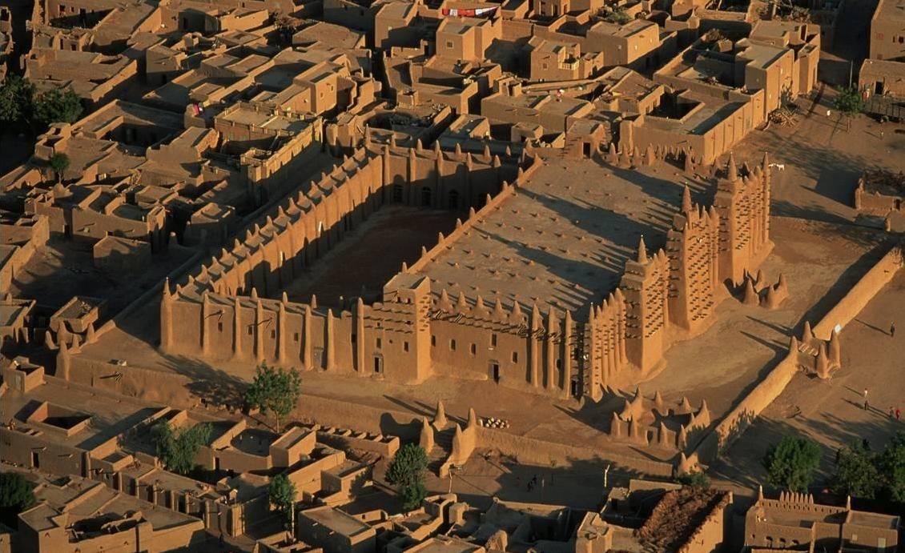

* A warning to the young and a reminder to the adults
* Nature’s dangers are objective
* From the still pond waters
* To the depths of a watering hole